Class 4 (Solution)
Yubo Rasmussen

Introduction
This notebook covers the Binomial Model with the Uniform Distribution of Deaths (UDD) and Constant Force of Mortality (CFM) assumptions. Additionally, it implements the Newton-Raphson method for numerical optimization.

Binomial Model: Uniform Distribution of Deaths (UDD)
Write down the loglikelihood function from Example 4.7 in terms of q and assign it as a named variable under the UDD assumption.
# Log likelihood function in terms of q
LogQ <- function(Q) 3*log(Q) +2*log(1-Q) - log(4-Q) - log(4-3*Q)
Write a function to plot the log-likelihood function above and call it.
# Plot log likelihood
PlotLogQ <- function(Left, Right){
Q <- seq(Left, Right, length = 1000)
plot(Q, LogQ(Q), type = "l", col = "blue", lwd = 2,
main = "Log likelihood for Q", ylab = "LogLikelihood(Q)")
grid()
}
# Plotting
PlotLogQ(0.67, 0.69)
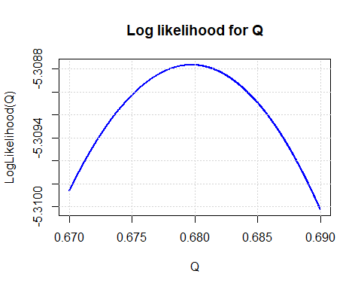
What are we looking for in this plot? - The maxima of this curve.
What do you think is a reasonable assumption for the value of Qhat? Assign and store it.
QHat <- 0.68
Write down the score function of Q. Can you explain how the score function is derived?
# Score for Q
ScoreQ <- function(Q) 3/Q - 2/(1-Q) + 1/(4-Q) + 3/(4-3*Q)
Now write a function to plot the Score function and call it.
# Plot of Score function
PlotScoreQ <- function(Left, Right){
Q <- seq(Left, Right, length = 1000)
plot(Q, ScoreQ(Q), type = "l", col = "red", lwd = 2,
main = "Score for Q", ylab = "U(Q)")
grid( )
}
PlotScoreQ(0.67, 0.69)
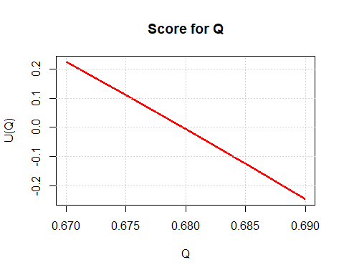
What are we looking for in this plot? - The value of Q when U(Q) is at 0.
What do you think is a reasonable assumption for the value of QHat? - 0.68
# And QHat = 0.68 again
QHat = 0.68
Now, it is time to compute the standard error of the estimated parameter QHat.
Use a numerical approximation by computing the difference quotient.
# SE numerical
Slope <- (ScoreQ(0.68+0.001) - ScoreQ(0.68-0.001))/0.002
SE <- sqrt(-1/Slope); SE
[1] 0.2059085
Use an analytical second derivative approach.
# And with second derivative
DUQ <- function(Q) -3/Q^2 - 2/(1-Q)^2 + 1/(4-Q)^2 + 9/(4-3*Q)^2
Slope2 <- DUQ(0.68)
SE2 <- sqrt(-1/Slope2); SE2
[1] 0.2059094
Do the two estimates of SE agree? - Yes

Binomial Model: Constant Force of Mortality (CFM)
Write down the loglikelihood function from Example 4.7 in terms of $μ$ and assign it as a named variable under the CFM assumption.
# Log likelihood function in terms of mu
LogMu <- function(Mu) - 1.75*Mu + 2*log(1-exp(-0.5*Mu)) + log(1-exp(-Mu))
Write a function to plot the log-likelihood function above and call it.
# Plot log likelihood
PlotLogMu <- function(Left, Right){
Mu <- seq(Left, Right, length = 1000)
plot(Mu, LogMu(Mu), type = "l", col = "red", lwd = 2,
main = "Log likelihood for Mu", ylab = "LogLikelihood(Mu)")
grid()
}
# Plotting
PlotLogMu(1.14, 1.16)
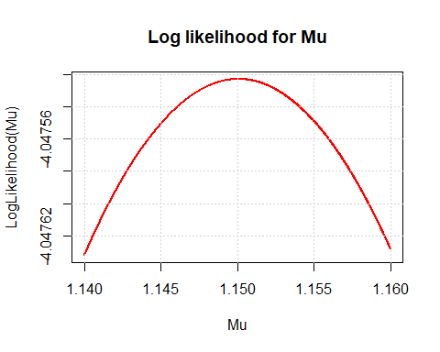
What are we looking for in this plot? - The maxima of this curve.
What do you think is a reasonable assumption for the value of MuHat? Assign and store it.
MuHat <- 1.15
Write down the loglikelihood function from Example 4.7 in terms of $ϕ=exp\left(−μ/4\right)$ and assign it as a named variable under the CFM assumption.
# Log likelihood function in terms of phi
LogPhi <- function(Phi) 7*log(Phi) + 2*log(1-Phi^2) + log(1-Phi^4)
Write a function to plot the log-likelihood function above and call it.
# Plot log likelihood for Phi
PlotLogPhi <- function(Left, Right){
Phi <- seq(Left, Right, length = 1000)
plot(Phi, LogPhi(Phi), type = "l", col = "red", lwd = 2,
main = "Log likelihood for Phi", ylab = "LogLikelihood(Phi)")
grid()
}
PlotLogPhi(0.748, 0.752)
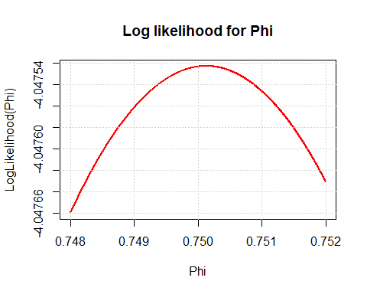
What are we looking for in this plot? - The maxima of this curve.
What do you think is a reasonable assumption for the value of PhiHat? Assign and store it.
PhiHat <- 0.750
Now check the consistency, i.e. is $ϕ=exp\left(−μ/4\right)$ close to $\hat{ϕ}$
exp(-0.25*MuHat)
[1] 0.7501366
Write down the score function for Phi. Can you explain how the score function is derived for Phi?
# Score for Phi
ScorePhi <- function(Phi) 7/Phi - 4*Phi/(1-Phi^2) - 4*Phi^3/(1-Phi^4)
Now write a function to plot the Score function and call it.
# Plot of Score function
PlotScorePhi <- function(Left, Right){
Phi <- seq(Left, Right, length = 1000)
plot(Phi, ScorePhi(Phi), type = "l", col = "red", lwd = 2,
main = "Score for Phi", ylab = "U(Phi)")
grid( )
}
PlotScorePhi(0.748, 0.752)
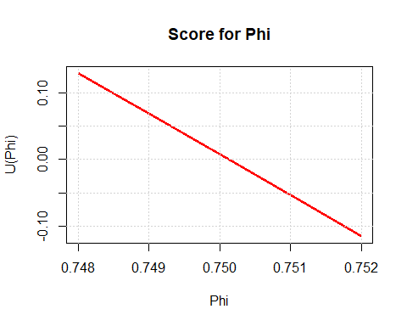
What are we looking for in this plot? - The value of Phi when U(Phi) is at 0.
What do you think is a reasonable assumption for the value of PhiHat? - 0.75
# And PhiHat = 0.75 again
PhiHat = 0.75
Now, it is time to compute the standard error of the estimated parameter PhiHat.
Use a numerical approximation by computing the difference quotient.
# SE numerical
Slope <- (ScorePhi(0.75+0.001) - ScorePhi(0.75-0.001))/0.002
Slope
[1] -61.06643
SE <- sqrt(-1/Slope); SE
[1] 0.1279672
Use an analytical second derivative approach.
# And with second derivative
DUPhi <- function(Phi) -7/Phi^2 - 4/(1-Phi^2) - 8*Phi^2/(1-Phi^2)^2 -
12*Phi^2/(1-Phi^4) - 16*Phi^6/(1-Phi^4)^2
Slope2 <- DUPhi(0.75)
SE2 <- sqrt(-1/Slope2); SE2
[1] 0.1279681
Do the two estimates of SE agree? - Yes
Repeat the above and write down the Score function and SE for mu, including a plot of the Score function.
# Score function and SE for mu
ScoreMu <- function(mu) {
phi = exp(-0.25*mu)
ScorePhi(phi) * phi *(-.25)
}
PlotScoreMu <- function(Left, Right){
mu <- seq(Left, Right, length = 1000)
plot(mu, ScoreMu(mu), type = "l", col = "red", lwd = 2,
main = "Score for Phi", ylab = "U(Phi)")
grid( )
}
PlotScoreMu(1, 1.3)
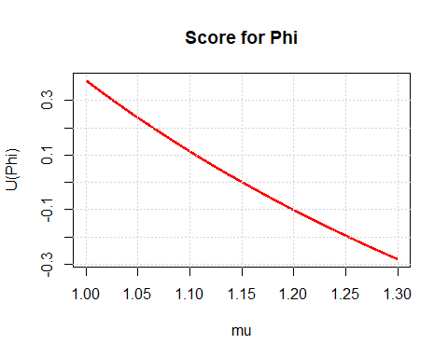
SlopeMu <- (ScoreMu(MuHat+0.001) - ScoreMu(MuHat-0.001))/0.002
SlopeMu
[1] -2.149347
SE.Mu <- sqrt(-1/SlopeMu); SE.Mu
[1] 0.682098
What can you say about the relationship between mu and phi? Why do we compute both of them? Which score function do you think is easier to derive analytically?

Newton-Raphson Method
Newton-Raphson is an iterative method used to solve equations of the form $f\left(x\right)=0$. The update rule for finding a better estimate of the root is given by:
$x_{n+1}=x_{n}−\frac{f\left(x_{n}\right)}{f′\left(x_{n}\right)}$
Since computing the analytical derivative $f′\left(x\right)$ is not always convenient, we use a numerical approximation.

Implementing the Newton-Raphson Method
# Newton-Raphson iteration using numerical differentiation
Newton <- function(f, x0, Delta){
Derivative <- (f(x0+Delta/2) - f(x0-Delta/2))/Delta
x0 - f(x0)/Derivative
}

Example: Finding the Square Root of 2
Square <- function(x) x^2 - 2
x1 <- Newton(Square, 1.5, 0.0001)
x2 <- Newton(Square, x1, 0.0001)
c(x1, x2, x2^2)
[1] 1.416667 1.414216 2.000006

Generalizing Newton-Raphson with a Loop
We can now define a function that iteratively applies the Newton-Raphson method until convergence:
Solve <- function(f, x0, Delta, Tol, Max.Iter){
TOL <- abs(f(x0))
Iter <- 0
while((TOL > Tol) && (Iter < Max.Iter)) {
Iter <- Iter + 1
x1 <- Newton(f, x0, Delta)
TOL <- abs(f(x1))
x0 <- x1
}
x0
}

Finding Roots of a Function
Root <- Solve(Square, 1.5, 0.0001, 10^(-6), 10)
c(Root, Root^2)
[1] 1.414214 2.000000

Applying Newton-Raphson to the Score Function of Q
Score <- function(Q) 3/Q - 2/(1 - Q) + 1/(4 - Q) + 3/(4 - 3*Q)
q.hat <- Solve(Score, 0.5, 0.0001, 10^(-6), 10)
q.hat
[1] 0.6797277

Alternative Root Finding Using uniroot()
The uniroot() function in R can also find the root of a function over a specified interval:
x.lower <- 0.001; x.upper <- 0.999
uniroot(Score, c(x.lower, x.upper))
$root
[1] 0.6797251
$f.root
[1] 6.191831e-05
$iter
[1] 6
$init.it
[1] NA
$estim.prec
[1] 6.576709e-05

Numerical Derivative of the Log-Likelihood Function
This works with a numerical derivative of the log likelihood function:
Log.L <- function(Q) 3*log(Q) + 2*log(1-Q) - log(4-Q) - log(4-3*Q)
Score.Num <- function(x) (Log.L(x + Delta/2) - Log.L(x - Delta/2))/Delta
Delta <- 0.0001
uniroot(Score.Num, c(x.lower, x.upper))
$root
[1] 0.6797251
$f.root
[1] 6.191399e-05
$iter
[1] 6
$init.it
[1] NA
$estim.prec
[1] 6.576218e-05

Checking the Score Function at the Estimated Root
Score(q.hat)
[1] -1.79412e-13
Score(uniroot(Score.Num, c(x.lower, x.upper))$root)
[1] 6.195374e-05
- How does the Newton-Raphson method compare to uniroot()?
- How does step size (Delta) affect convergence?
- What are the advantages of using Newton-Raphson in maximum likelihood estimation?

